What is an IRQ?

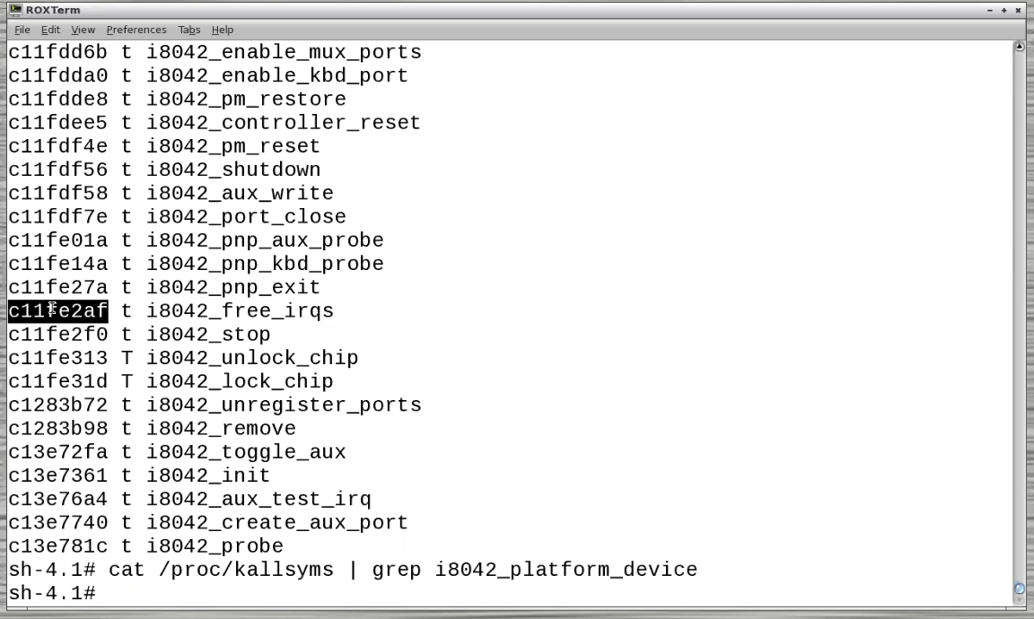

Is every memory space mapped to a function, or is it just the puppy linux designated space

Use the defined code of iotcl on a device we create on /proc, which is a dummy file.

That file exists so that we can spawn file descriptions on it,

Sys_open() opens the body of the kernel core for the inside of the kernel, which you’re already in.

Exactly what people do when people write root kits (replace functions in memory)

Int foo(int, char):

Foo = 0xc10000000;

Foo(arg1,arg2);

(*0x10000000)arg1, arg2);

Calls functions in /etc/rc.d to load in functions

Free irq vs disabled irq (free irq, release, disabled to associate)

Wake queues call schedule while it is active in the interrupt service routine

So when you wake up from the wait queue you aren’t in the interrupt service routine